# **Quantum Machine Learning**

Quantum computing is a branch of computer science that uses the quantum physics concepts to solve problems and statements that regular or classical computers can’t solve. Like the bits in the classical computers, the quantum computer uses qubits capable of solving complex problems and passing the information to each other.

Quantum Machine Learning (QML) is an interdisciplinary field that combines principles and techniques from quantum computing with machine learning algorithms. Its aim is to leverage quantum computing's unique properties, such as superposition, entanglement, and quantum parallelism, to enhance the efficiency and capabilities of machine learning tasks.

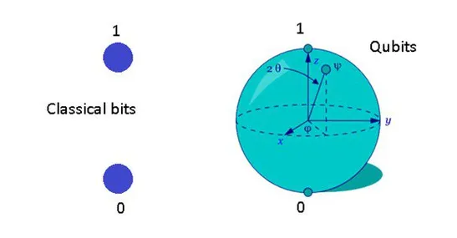

Here, qubits surpass standard bits found in classical computers in terms of sophistication and data storage capabilities. Additionally, qubits can be conceptualized as specific waves in Quantum algorithms physics responsible for containing and transmitting information and data.

It is better to compare classical and quantum machine learning to get a clear idea. However, before comparing them, let us compare normal programming and machine learning.

**Key Concepts in Quantum Machine Learning:**

**Quantum Computing Basics:**

**Qubits**: Quantum bits, the fundamental unit of quantum information, which can exist in superpositions of states.

**Quantum Gates:** Analogous to classical logic gates but operate on qubits and can create entanglement and superposition.

**Quantum Parallelism:** The ability of quantum systems to explore multiple possibilities simultaneously.

**Entanglement:** A quantum phenomenon where the state of one qubit is correlated with the state of another, even when separated by large distances.

### **Quantum Advantage in Machine Learning**

* Enhanced Optimization: Quantum algorithms can solve certain optimization problems, such as finding the global minimum of a complex function, more efficiently than classical algorithms.
* Improved Pattern Recognition: Quantum systems can exploit quantum mechanical phenomena, like superposition and entanglement, to identify patterns in data more accurately and efficiently.
* Enhanced Simulation and Modeling: Quantum computers can simulate complex quantum systems, which is crucial for applications like material science, drug discovery, and climate modeling.
* Faster Data Processing: For some data processing and Machine learning models applications, like database searches and machine learning model training, quantum algorithms may provide appreciable speedups.
* Speed-up in Computations: Quantum algorithms can potentially provide exponential speed-ups for certain tasks, such as searching and optimization, compared to classical algorithms.
* Feature Mapping: Techniques like quantum kernel methods can transform classical data into a quantum space, potentially revealing more complex patterns.

## **Challenges and Limitations**

* Hardware Limitations: Current quantum computers are still in the early stages of development and face challenges such as limited qubit count, error rates, and scalability.
* Algorithm Development: Designing efficient quantum machine learning algorithms that can outperform classical methods is an active area of research.
* Data Availability: The successful application of quantum machine learning often requires access to large, high-quality datasets, which can be a limitation in certain domains.
* Integration with Classical Systems: Integrating quantum ML with traditional computing systems and existing infrastructure is an ongoing challenge.

The possible uses of quantum machine learning models are anticipated to grow as quantum technology develops further, providing fresh chances for improved problem-solving and creative solutions in a range of fields and sectors.

## **Types of Quantum Machine Learning**

Quantum machine learning combines quantum algorithms and machine learning techniques to improve the speed and accuracy of learning from data. It uses quantum physics and quantum computers to enhance the capabilities of machine learning. There are different types of quantum machine learning, such as:

### **Quantum Neural Networks (QNN)**

These are neural networks that operate on quantum logic gates and qubits, which are the basic units of quantum information. QNNs can leverage quantum phenomena such as superposition and entanglement, enabling qubits to simultaneously exist in multiple states and exhibit correlation with each other. QNNs can perform faster and more efficient learning than classical neural networks.

### **Quantum Support Vector Machines (QSVM)**

These support vector machine learning models that use quantum algorithms to find the optimal hyperplane that separates the data points into different classes. QSVMs can use quantum speedup and quantum parallelism, which enable quantum computers to perform multiple operations simultaneously and solve complex problems faster than classical computers.

### **Quantum Reinforcement Learning (QRL)**

These are reinforcement learning algorithms that use quantum agents and quantum environments to learn optimal policies and actions. QRL can use quantum resources and quantum feedback, which provide quantum agents with more information and better rewards than classical agents.

## Applications of Quantum Computing

#### **1. More Faster Algorithms**

With the help of quantum computing, we can make the algorithm’s training on more enormous datasets faster and more efficient. The QML algorithms can be super faster compared to classical machine learning where qubits will play a major role.

#### **2. Solving Complex Data Patterns**

Quantum computing can assist in solving complex data patterns that cannot be addressed by classical machine learning and deep learning algorithms. Very complicated datasets where data correlations and patterns are not recognisable and solvable, the QML can make it possible.

#### **3. Develop Advanced Algorithms**

Quantum computing, with the integration of machine learning can help build and design more advanced machine learning algorithms. Advanced algorithms integrated with quantum computing can solve more problems in less time with greater accuracy.

#### **4. Advancement in Reinforcement Learning**

Reinforcement learning stands to benefit significantly from the incorporation of quantum computing concepts. Novel concepts within reinforcement learning can be developed and enhanced through quantum machine learning utilizing qubits.

#### 

#### **5. Advanced Computer Vision**

Quantum machine learning can also help advance the computer vision application and make the existing deep learning algorithms quicker and more efficient. With the help of quantum machine learning, we can develop more advanced and accurate image segmentation and processing applications.

## **Machine Learning vs. Quantum Machine Learning**

As we discussed, machine learning is a set of programs that takes the data as input, preprocesses it, and learns from it. Then, the testing data is used to evaluate the model, and the model’s loss is calculated.

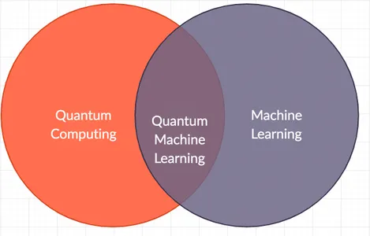

We take the ideas of atoms and molecules from quantum physics and train the model on training data rather than the bits level. In quantum ML, we utilize qubits, which are far more advanced than regular bits. We also test the model on the testing data after its training, calculate the loss function, and try to minimize the same.

## **What Exactly is Quantum Machine Learning?**

Now as we have an idea about classical programming, machine learning, and quantum computing, it is the best time to learn about QML. This process entails integrating classical machine learning with quantum computing, leveraging quantum computing to apply ML concepts and techniques instead of relying solely on classical computing and programs.

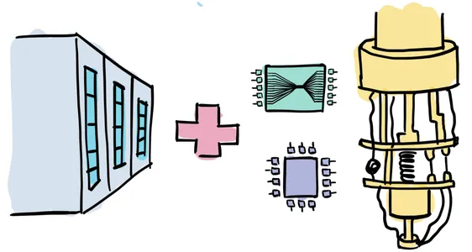\

As the standard or classical computer works with bits with either the value 0 or 1, the same quantum computers have qubits or quantum bits, which also store the data. Still, it leverages the principle of superposition, which means that, unlike the classical bits, the qubit can be in multiple states simultaneously.

To understand the principle of superposition, let us take an example. We have a coin. We toss it, and now it can give us a tail or a head. Before launching the cos’s or while the coin is flipping in the air, we can’t say it’s in a heads or tails state. That means it is partially in heads and tails, according to the person’s view. Here, we refer to the principle known as the superposition of the coin, where the coin can exist in multiple states simultaneously.

**Tools and Platforms for Quantum Machine Learning:**

Implementing and running quantum machine learning algorithms typically requires access to quantum computing platforms or simulators that support quantum operations and algorithms. Here are some tools and platforms where you can explore and experiment with QML:

**IBM Quantum Experience:**

Provides access to real quantum hardware and simulators via the cloud.

Offers Qiskit, a quantum computing SDK in Python, which includes tools for quantum machine learning experiments.

**Google Cirq:**

An open-source framework for creating, simulating, and running quantum circuits on quantum computers and simulators.

Supports research and development of quantum algorithms, including machine learning applications.

**Microsoft Quantum Development Kit:**

Includes Q# programming language for expressing quantum algorithms.

Provides access to Azure Quantum, a cloud service that allows you to run quantum programs on quantum hardware or simulators.

**D-Wave Systems:**

Specializes in quantum annealing technology, which is used for optimization problems.

Offers Leap, a cloud-based platform for developing and running quantum applications, including machine learning.

**Amazon Braket:**

A fully managed service that allows scientists, researchers, and developers to explore and experiment with quantum computing.

Supports integration with classical cloud computing services for hybrid quantum-classical computations.